13.Car Price Prediction Model using Python

Aim
To implement a Car Price Prediction Model in Python using a machine learning algorithm and predict the price of a car based on its features.

Algorithm
- Import the required libraries.
- Create a dataset containing car features and prices.
- Separate the input features and target price.
- Split the dataset into training and testing data.
- Create a Linear Regression model.
- Train the model using the training data.
- Predict the car prices for the test data.
- Calculate the accuracy using R² score.
- Predict the price of a new car.
PROGRAM:
from sklearn.linear_model import LinearRegression
from sklearn.model_selection import train_test_split
from sklearn.metrics import r2_score

X = [
[2015, 50000, 1200],
[2016, 45000, 1300],
[2017, 40000, 1400],
[2018, 35000, 1500],
[2019, 30000, 1600],
[2020, 25000, 1700],
[2021, 20000, 1800],
[2022, 15000, 1900],
[2023, 10000, 2000],
[2024, 5000, 2100]
]

y = [
500000,
550000,
600000,
650000,
700000,
750000,
800000,
850000,
900000,
950000
]
X_train, X_test, y_train, y_test = train_test_split(
X, y, test_size=0.2, random_state=42
)
model = LinearRegression()
model.fit(X_train, y_train)
y_pred = model.predict(X_test)
accuracy = r2_score(y_test, y_pred)

print("Actual Prices:", y_test)
print("Predicted Prices:", y_pred)
print("R2 Score:", accuracy)
new_car = [[2022, 12000, 1900]]
predicted_price = model.predict(new_car)
print("New Car Details:", new_car)
print("Predicted Car Price: Rs.", round(predicted_price[0], 2))
OUTPUT:
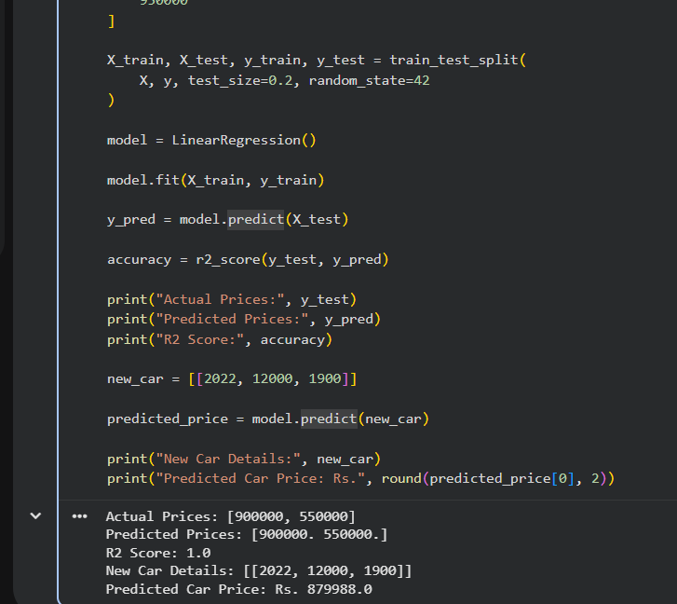
RESULT:
Thus, the Car Price Prediction Model was successfully implemented using Linear Regression in Python, and the price of a new car was successfully predicted.

